REPLACING RUBBER SEALS ON THE LUVAX/GIRLING DAMPERS

by

TERRANCE J. VAN PARYS

TC 3452

The Girling dampers on the TC are pretty simple - straightforward in design and function. They are sturdy and really have little that requires attention, but for one spot – the rubber shaft seal that eventually deteriorates and results in loss of damper fluid.

When I took the dampers off of TC 3452, I had every intention of sending them off to have them rebuilt when my ground-up rebuild got to the stage of requiring their reinstallation. All were oil-soaked and practically empty, due to the seals on the lever/arms being deteriorated to the point of being non-existent. Three assignment moves and six years later, I reached the point in early summer of this year when it was time for the dampers to go back on. Trying to keep the rebuild on budget and being curious as to how the dampers were put together, I decided to forego the $600 trip to any of the more popular repair facilities advertised in Hemmings. Instead, I would replace the seals myself.

But where to start? Having recently joined the T-ABC Forever folks on the web, it turns out that there was a wealth of information from folks much more knowledgeable than I on the subject. Several said they knew how to get to the seal I needed to replace, one had an old stock number for a replacement seal and others were helpful with the internal workings of lever dampers. All I did was a little research on the web, found a current source for the seal, and put all the knowledge together.

Before I get started, let me begin by clarifying the intent of this project. I was mainly interested in making the dampers serviceable. This would allow me to ride in comfort (relative for a TC) and would also lessen the number of oil puddles at any one time on my garage floor. To do this, I would need to replace the rubber shaft seals. While I also ensured that piston by-pass ports (pressure valve and return valve holes) were clear when I had the dampers partially apart, I had no intention of attempting to remove pistons, nor did I perform, checks on the metering valve or ensure that the pistons were passing a specific amount of fluid through with each stroke. I merely cleaned the bores up of any corrosion and debris, and left the valves at their factory settings. Did I do as well for $69 (not counting oil and, of course, my labour) as the pros that do this for $600? I don’t know. Do the dampers hold oil and work properly (the project’s objective)? Yes, so far. But since this is a from-the-ground-up rebuild, the real test probably won’t come until the car is up and running and the dampers have a few thousand miles on them. With that in mind, I’ll begin.

All but one damper had total front seal failure, so draining them was not a real problem (as evidenced by my garage floor at one time). I removed the filler plug, turned the damper upside down over a large coffee can, and slowly moved the lever to its full extension in each direction. This ensured that as much oil still trapped in the compression chambers made its way to the recuperation chamber in the top and on out the filler hole. Once drained, the filler plug was replaced and a general inspection was in order.

I began by thoroughly cleaning the outside of the dampers, which allowed me to see any cracks or damage that might require repair. This cleaning is also essential to prevent foreign material from falling into bores and chambers when covers were later removed. Once clean, the top piece (recuperation chamber) was removed, being held in place by four screws. Be careful not to pry this off at the ears where the screws go in. It is made from a much softer material than the damper body and can be easily damaged with careless prying. I carefully removed a recuperation chamber gasket on one damper and used it as a template to cut new ones for all four.

Next, the damper ends were unscrewed and the inside of each given a general inspection. Three of my dampers appeared to have over 50 years of gunk and sludge, but were in good, overall condition. The fourth one was the same, except that the lack of oil (due to the deteriorated seal) had caused the pistons to rust in place. A few hours on end with some WD-40 penetrating oil soaking in the bore freed everything up. I then removed the rust from the pistons.

Once the pistons were clean and all of the crud was out of the bores, I gave them a thorough cleaning with WD-40. I ensured that the piston return-valve holes were clear by shooting the WD-40 into the holes with the thin extension that comes with the can. I filled the damper partially with penetrating oil then worked the lever up and down to the full extent. This allowed the penetrating oil to flush out the piston metering ports. When I was satisfied that everything was free and clean, I drained the dampers, removed the ends and cleaned any residual debris from this flushing. After checking the condition of the end-cap gaskets for serviceability, I put the ends back on again, only hand tight. This was to keep the bores as clean as possible and to protect the machined threads on the end of the dampers from damage when it went to the machinist.

Now that the dampers appeared serviceable and in good, overall condition, it was time for the seal replacement. There are two ways to get at the rubber seal that sits behind the lever/arm. The first way is to remove the damper arm from its shaft. While this is more direct, it actually turns out to be the hard way of doing business, since it requires grinding off (or otherwise removing) the flair at the rod end in order to remove the arm. You are then left with an unknown condition of the part of the shaft that remains in the damper. In addition, you must also somehow secure the arm back onto the shaft once the seal is replaced.

The second method is to press the shaft, with attached arm, out of the damper, then press the shaft back into place once the seal is replaced. This second method is the one that I used.

To gain access to the blind end of the shaft, I first removed the 1 1/8 inch metal disk on the back side of the damper. “Easy as removing an engine freeze plug,” I thought. Hmmm. Well…not quite. What should have been one of the easiest parts of the project turned into a real time-consumer. But patience and persistence paid off. After trying several methods (and breaking a number of screwdrivers) the most effective way was to first drill a ½ inch hole in the center of the disk. This was followed by ¼ inch holes on each of the four sides of the center hole. I then chiseled the metal between the center and each of the smaller holes. In the end, I had what looked like a cross of holes. I was then able to more easily pry out the disk.

I’ve corresponded with others who have suggested drilling a small hole in the center, then screwing in the end of a slide hammer and pull it out that way. Didn’t have one, so I didn’t try it, but it sounds feasible. However you do it, just be careful you don’t drill too far down and start to drill into the end of the shaft or the surrounding damper material that sits about 1/8 inch below the bottom of the disk dome (and even closer around the edges). Drill and check. Drill some more and check it again. If the disk has never been removed, there should be a red gasket (similar to the damper end-cap gasket material) the same diameter as the disk sitting between the disk and the shaft end. If this gasket material starts coming out on your drill bit, it means you have drilled through the disk and it’s probably time to stop.

Once the disk was off, I reached for the can of WD-40/ penetrating oil again. I propped up the damper so it was face (arm-side) down. I filled the indentation where the disk sat with penetrating oil and let it sit overnight. I wanted the oil to seep down the shaft and into the splines where it is connected to the piton crank to ensure that it was free to press out. The more oil that gets down there, the easier it will be to press out the shaft. I had plenty of paper towels under this to catch the excess oil as it seeped down the shaft and out the other end. I gave my dampers three or four treatments each. I would fill the area with oil in the morning before I left for work, then again in the evening when I came home. Patience here is the key. You want these shafts well lubed and free of binding.

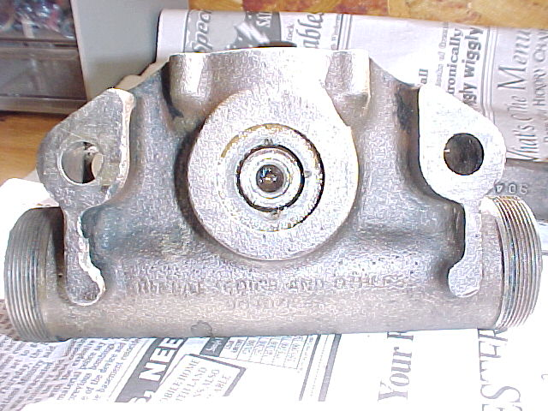
Figure 1: This is what lurks behind the disk and disk gasket. After disk was removed, the damper was placed with this side up and the entire disk area was filled with penetrating oil. I let it soak for several days, keeping this area full. Idea is to make pressing the shaft out as easy as possible. Don't forget to place folded paper towels or rags on the under side to catch oil once it penetrates through.
Before I pressed out the shaft, I marked everything so that the shaft and arm ended up in the same place and had the same relative position to the damper at each extent of its swing. Looking inside the damper from the top, I found a single punch mark already on the piston crank. This may have been done at the factory to ascertain center (middle of up/down stroke). I put this on top center, then punched my own mark adjacent to it on the inside body. With these two marks lined up, I then made a mark on the outside of the damper on the arm (directly above the shaft) and a corresponding mark on the damper body (Figure 2). These marks would be aligned again when the shaft was reinstalled.

Since I was without a press, off I went, dampers in hand, to a machinist. I actually went to two machinists for this project. I only took one damper in at first, to see what kind of a job they would do. That was a fortunate move. I explained to the first machinist what I needed done, then left. Somewhere along the way in the days that followed, he decided it would be better to grind away the flare on the end and remove just the arm (the first method described, above). It was a sloppy job, it was not what I asked for, and I was not happy. Not only could I not see the condition of the shaft and spline area, but I had to then put the seals in with the shaft in place (I ended up using a piece of 1-inch diameter PVC pipe drive the seals in place on this damper).

Fortunately, the second machinist I found could follow directions. Even better, he let me watch as he did it (since it appeared to be a simple job, he did it right away for me). The key to pressing the shafts out safely (without damage to the damper body) is to ensure that the face (front) of the damper rests on as much surface area as possible when the shaft is being pressed out from the other side. My machinist placed large metal nuts under the area where the bolts that attach the damper to the chassis go through. This allowed the damper to rest mainly on this attachment area (already made to take a good deal of load). Fortified with success, I took the remaining dampers in and had him press these shafts out.

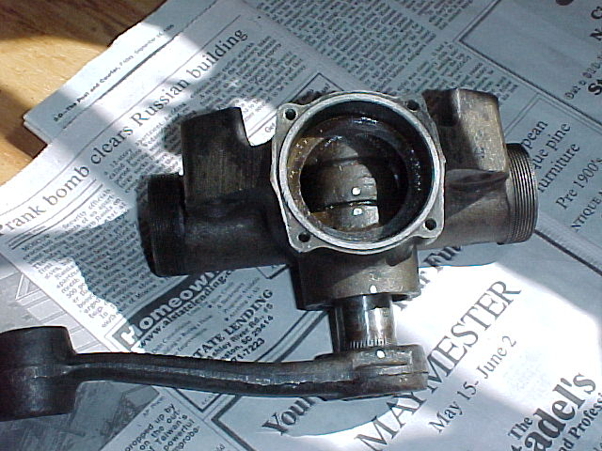

Figure 2: Center punch marks (highlighted here with white paint) on piston crank (top mark) and body. Similar marks made on outside body and arm. After seal installation, marks are used to align shaft, arm and piston crank, so that all will be in the same relative position as when removed. (Note that picture shows shaft after it has been pressed out, hence the gap between the body and the arm).

Once back to my own workbench, I cut out the remains of the old seals and cleaned the seal area, shaft holes, spline area and shafts with acetone, then wiped everything dry. Once the seal was out, I noticed a small hole that runs through from the top of the inside of the damper to the face of the seal area. I have received different answers from different people as to the purpose of this tiny hole. Some have stated that it is for overflow, some say it is a differential pressure port. I ensured that it was clean and free from debris by using the nozzle extension from my trusty WD-40 can, running it in the hole and “pressure washing” it clean with a couple of squirts.

The seals themselves appear to be available from several sources. Through a part number given to me by fellow T-ABC member Jack Emdall, I was able to track down the seals made by Federal-Mogul, Inc. After some web work and a few phone calls, I confirmed that Federal-Mogul still made these. I purchased them through All Seals, Inc., 404 West Rowland Avenue, Santa Ana CA 92707-3479, USA (phone number for orders is 1-800-843-1793). The seal (Federal Mogul seal # 340413) is a lip seal, 1.314 inch O/D, .875 (7/8) I/D and is .250 (1/4) inch thick. Since the original seal that I replaced was approximately ½ thick, I used two seals per damper. This came out just right because All Seals said that the minimum order they could get for me from Federal- Mogul was eight seals.

The seals were pressed in one at a time, one on top of the other. I lubed the seals with silicone spray to help them slide easily into place. They can be tapped in using a seal driver, but I simply used a 15/16-inch socket, which fit nicely. Once they were in place, I thoroughly lubricated the shafts and splines with oil, lined up all of the marks and placed the shaft back in. With the shafts cleaned and lubricated I was able to fully seat each shaft into place without damage, using a copper knockoff hammer. A wooden block will also work.
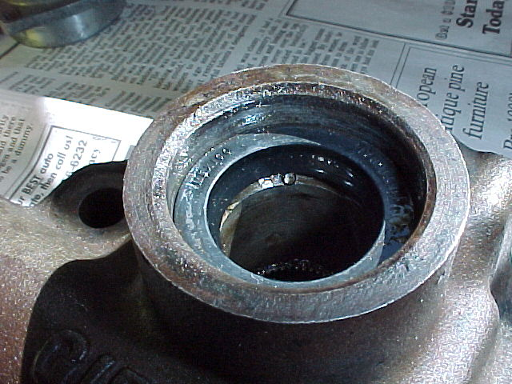
Figure 3: First seal in place. Ensure hole (arrow) is clear of obstruction (see text). Second seal fits in place right on top of this one.
The key here was to ensure the shaft splines were engaged in the piston crank hole and the marks were all lined up before tapping in to prevent misalignment or damage to the spline area. Once this was accomplished, it was time to cover the back of each damper shaft end area with a new disk.

The disks that cover the shaft ends are nothing more than 1 1/8 inch engine “knockout” or “freeze” plugs found at almost any automotive parts store. While they also come in brass and aluminum, I chose to stay with the original steel plugs. Using the disks as a template, I cut the gasket that will go under each disk. This gasket will help prevent sealant from getting onto the shaft end when the disks are driven in place. I used Permatex 2 (non-hardening formula) gasket sealant around the edges of the disk before I installed them on top of the gasket. Once in place, the disks are seated just like any freeze plug – with a moderate rap or two onto their center with the rounded end of a ball-peen hammer.

Before the end caps could be put into place, the machined threads on both the caps and the dampers were cleaned thoroughly. I planned to use Permatex 2 on these threads, so wanted to ensure that there was nothing that would prevent maximum adherence. I used a scribe to ensure that the grooves were clear of any sealant or debris, cleaned the area with acetone, then scrubbed the same area with a grease-cutting dish washing detergent and water. After drying the area thoroughly, I coated the threads on the damper body (not the caps) with Permatex 2. You want enough to ensure that the compression chamber ends are provide with a good seal, but not so much as to have the excess ooze into the bore and gum up the pistons when the caps are screwed back into place. A small line, rubbed flush with the threads and spread evenly around the entire circumference on each end should be enough to prevent oil seeping out at these points. The ends were then screwed back in place and tightened with wrenches.

With all the seals and plugs in place, I then scrubbed the dampers of any oil and grease before painting them black. I masked off the recuperation chambers and left them their aluminum colour, as I thought it would be a bit easier to see when topping up in place on the car in the years to come.

Lacking access to Lockheed damper oil, I used 20-weight motorcycle fork oil. Fork oil has the anti-foaming agent required for use in applications such as lever dampers and is readily available at almost any motorcycle shop. Also, 30-weight fork oil is available for those who prefer a firmer ride.

I removed the recuperation chamber for filling, as it made it easier and less messy then trying to use the small fill port. I then carefully worked the lever its full extent in each direction to expel air from the compression chambers, topping the oil up as required. When I no longer saw bubbles coming up, I put the recuperation chamber in place, fastened it down with the four screws, topped off the oil through the center fill port and secured the fill bolt. For those wondering, it took about a pint to fill all four dampers.

The dampers were then ready for new link bushings, then installation onto the chassis.

Project time: Approximately 16 hours labour - including time spent at the machinist (does not include leak-check, and “soak” times).

Project cost:

Eight seals (@$4.50 each plus COD shipping) $45
Four 1 1/8 inch freeze plugs (@ 1.00 each) 4

Machinist (press out 4 shafts) 20
One quart motorcycle 20 wt. fork oil 8

Total cost $77

